Fatima Jinnah Women University


PROJECT SUBMISSION

Automated Server Provisioning and Configuration System

Course Title : Cloud Computing

Submitted By :
Saira Ejaz ( 2023-BSE-057 )
Shumail Zahra
( 2023-BSE-061)

Submitted To:
Prof. Waqas Saleem

Dated:
January 23, 2026

Department Of Software Engineering
Fatima Jinnah Women University

Project 2

Automated Server Provisioning and Configuration System

Repo Link:

https://github.com/2023-BSE-057-Saira/Project-2-Automated-Servers

1. Executive Summary
This project demonstrates the automation of server provisioning and configuration management using Terraform and Ansible. It provisions EC2 instances for web and application servers in AWS and applies configurations using Ansible roles. Configuration drift detection and remediation are implemented to maintain consistency and security. Terraform workspaces manage multiple environments such as dev, staging, and production. End-to-end validation ensures web and app services are running correctly and SSH security is enforced.

2. Architecture & Design

Terraform Workspaces & Infrastructure

Terraform is used to create AWS EC2 instances for web and application servers.Multiple workspaces (dev, staging, production) are used to separate environments, allowing independent deployments. Outputs from Terraform include public and private IP addresses for all servers.

The main Terraform files used are main.tf, variables.tf, outputs.tf, and backend.tf.

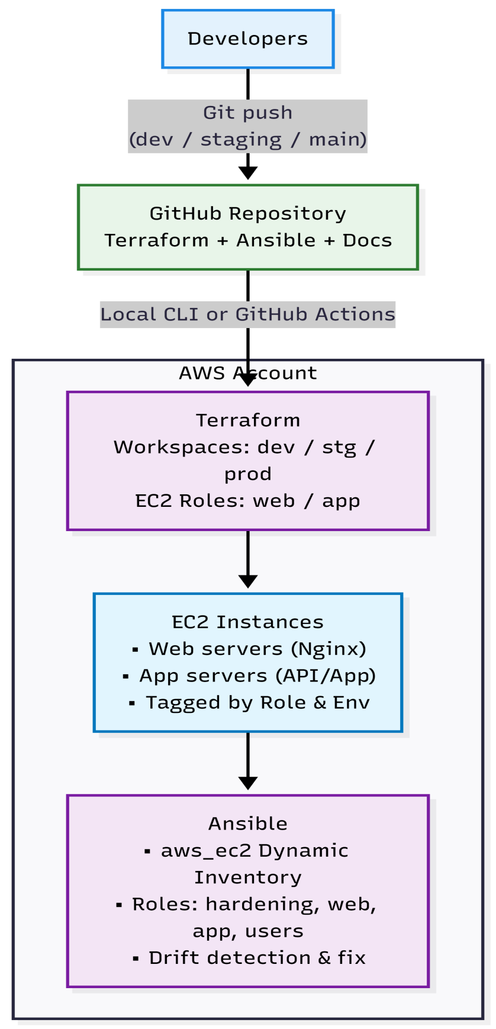

Implementation Details

Terraform initializes and applies infrastructure, generating outputs such as instance IDs and IP addresses. These outputs are used to configure Ansible inventory files. Ansible then connects to the servers, verifies connectivity, and configures web and application services. Both servers were successfully deployed and accessed.

Part 1: Git Repository Setup (15 marks)

Repository Structure (5 marks)

Tasks:

Create all directories and placeholder files.

Implement .gitignore for Terraform/Ansible/credentials (see 1.3).

Initialize Git repository and create an initial commit.

Deliverables:

Screenshot: project2_part1_repository_structure.png

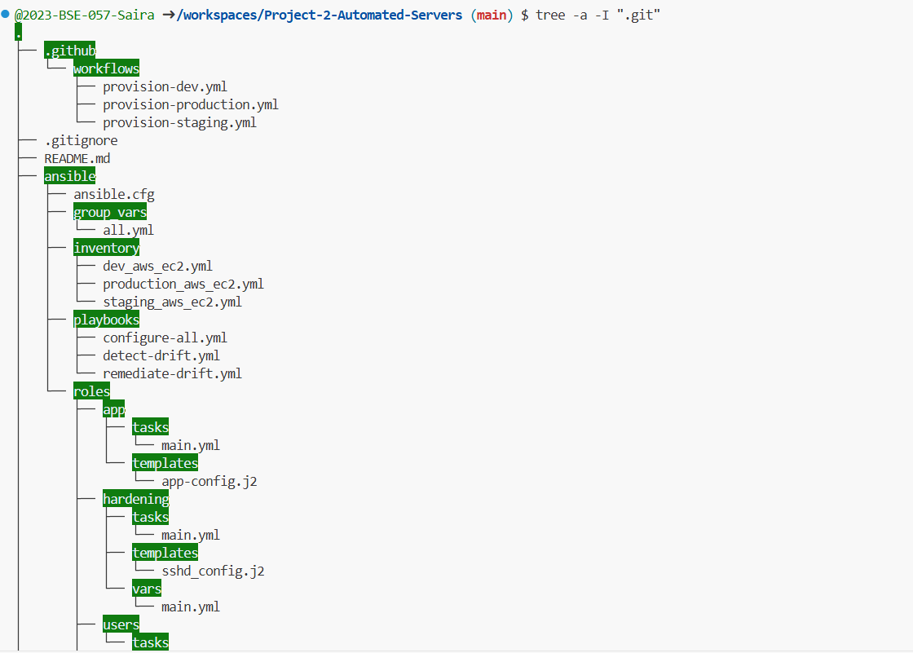

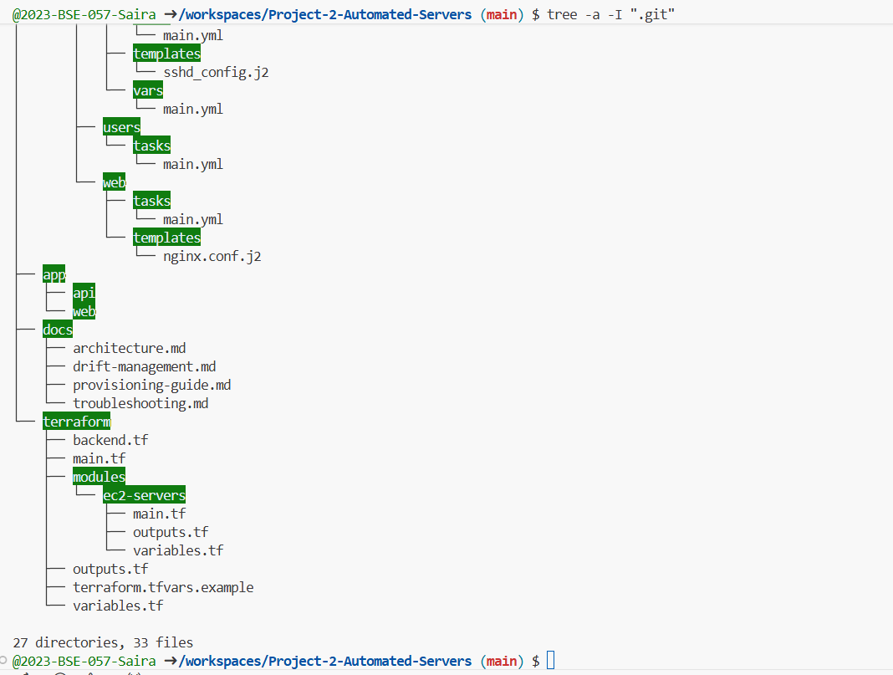

Screenshot: project2_part1_gitignore.png

Screenshot: project2_part1_initial_commit.png

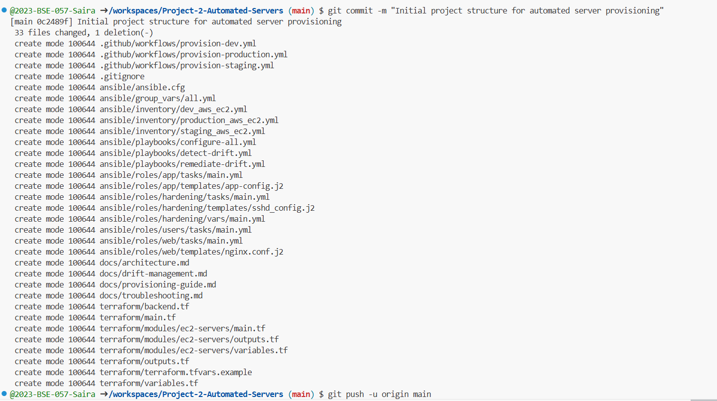

Git Branching Strategy (5 marks)

Tasks:

Create dev and staging branches from main.

Configure branch protection rules on main and staging.

Document branching strategy in README.md.

Create a sample feature branch (e.g., feature/add-ssh-hardening).

Deliverables:

Screenshot: project2_part1_git_branches.png

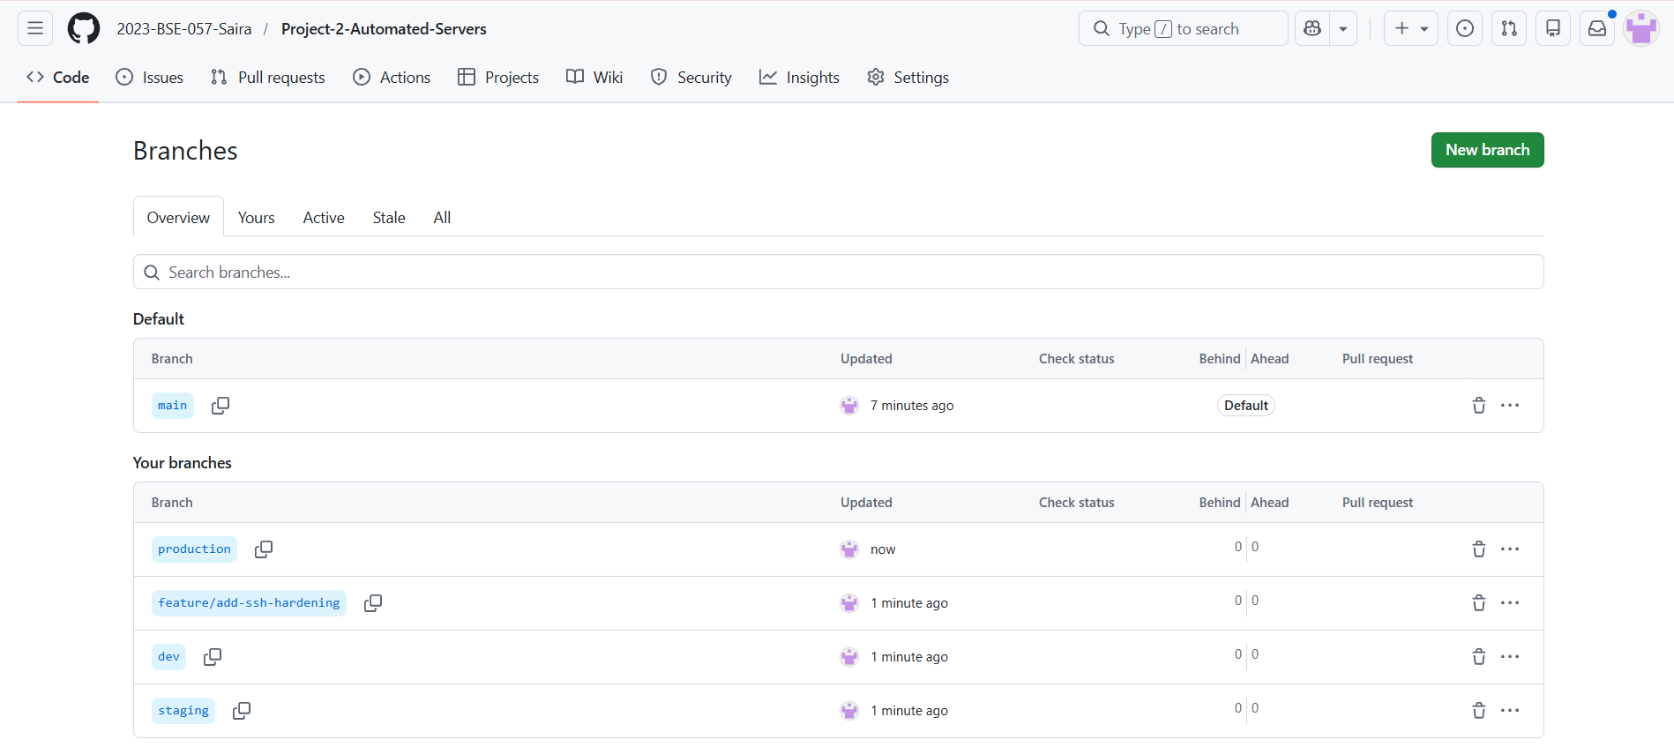

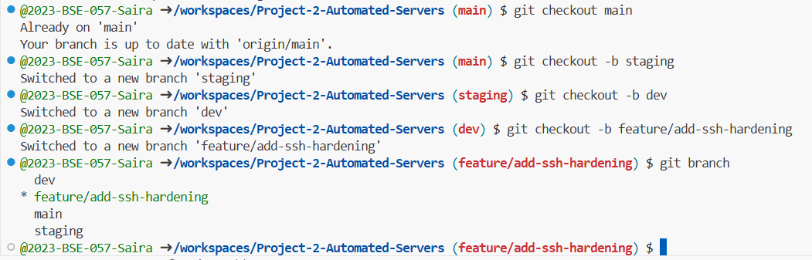

Screenshot: project2_part1_branch_protection.png

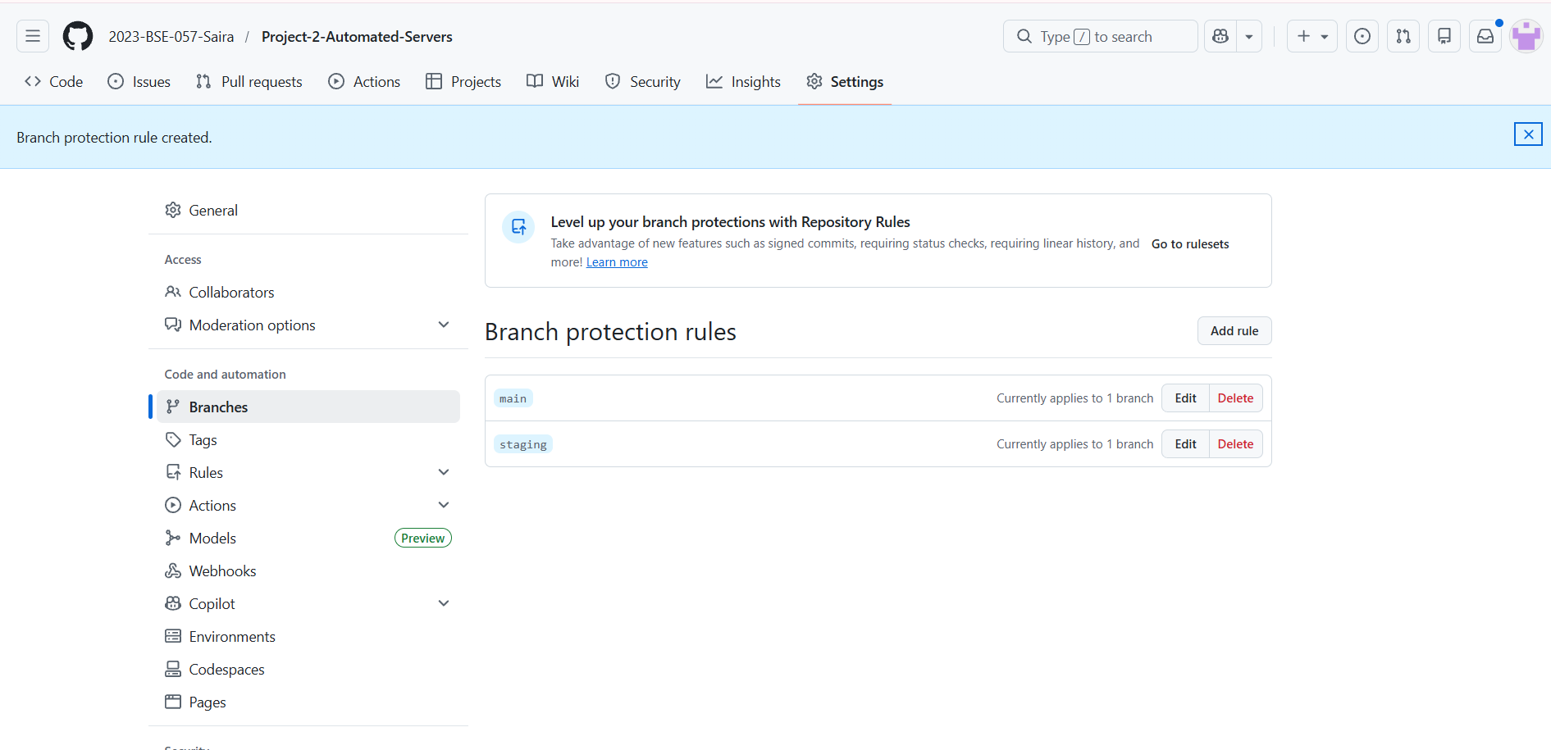

Screenshot: project2_part1_branching_diagram.png

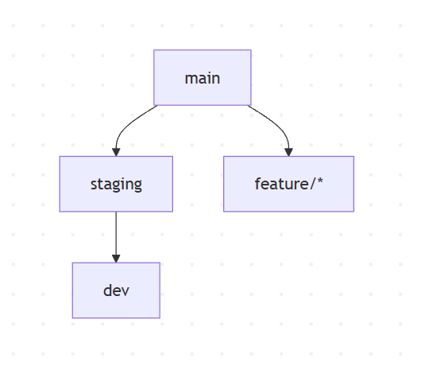

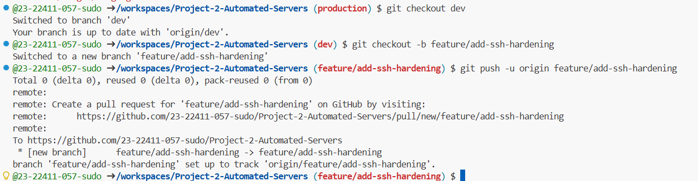

.gitignore Configuration (5 marks)

Tasks:

Add .gitignore with the rules above.

Verify no sensitive files or state are committed.

Document key ignore rules in README.md.

Deliverables:

Screenshot: project2_part1_gitignore_content.png

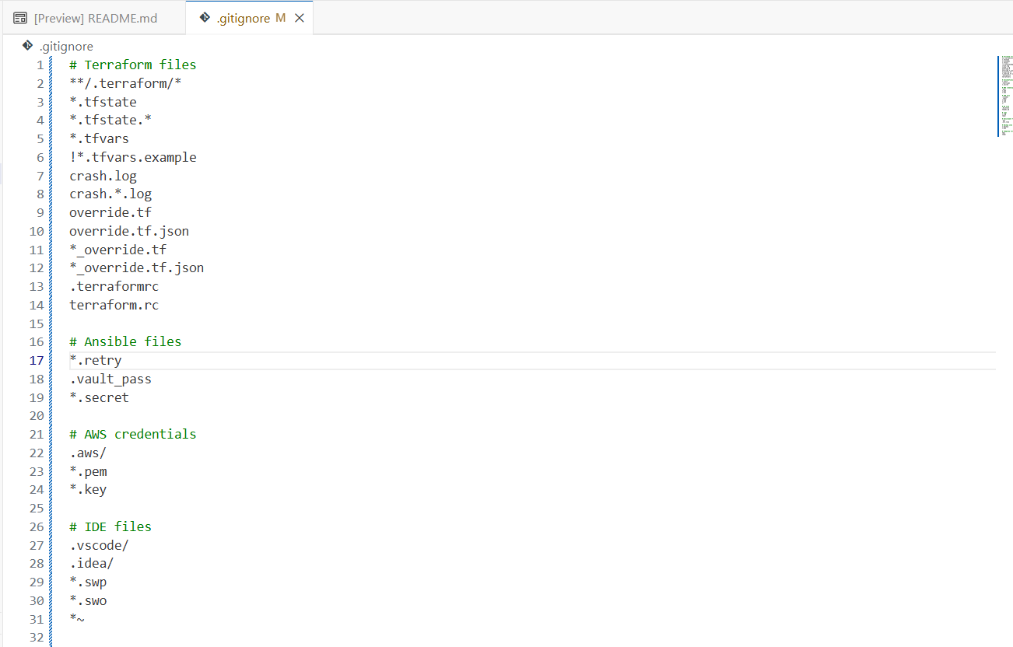

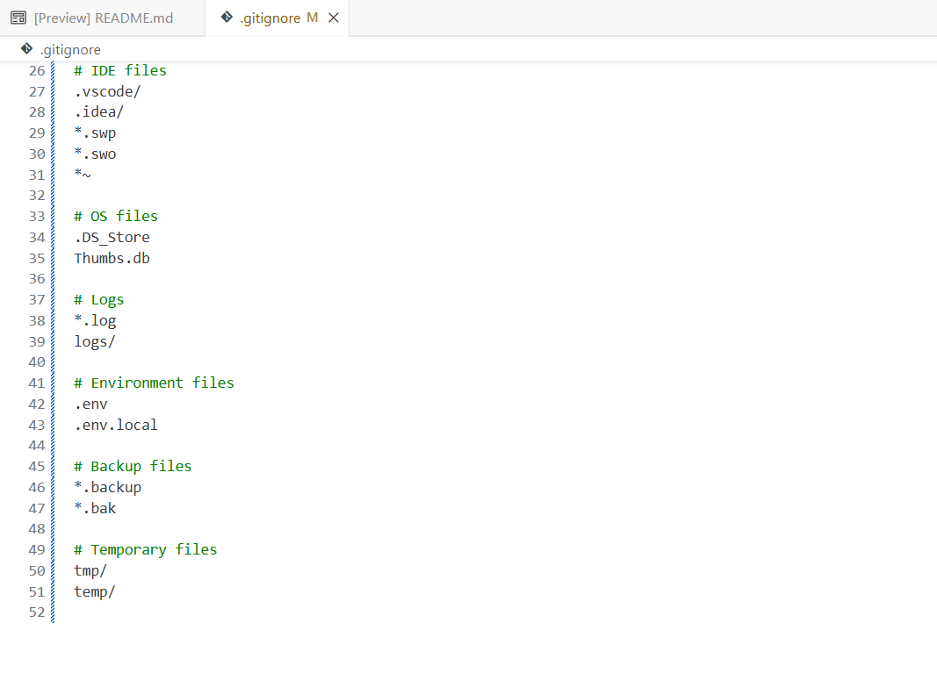

Screenshot: project2_part1_git_status_clean.png

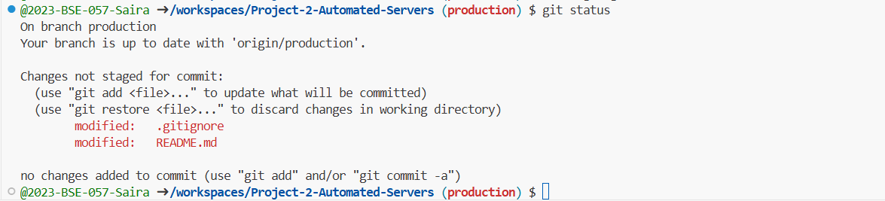

Part 2: Terraform Infrastructure (30 marks)

2.1 EC2 Servers Module (15 marks)

Tasks:

Implement web and app EC2 resources.

Tag instances with Project, Environment, and Role.

Output instance IDs and IPs.

Deliverables:

Screenshot: project2_part2_ec2_module_variables.png

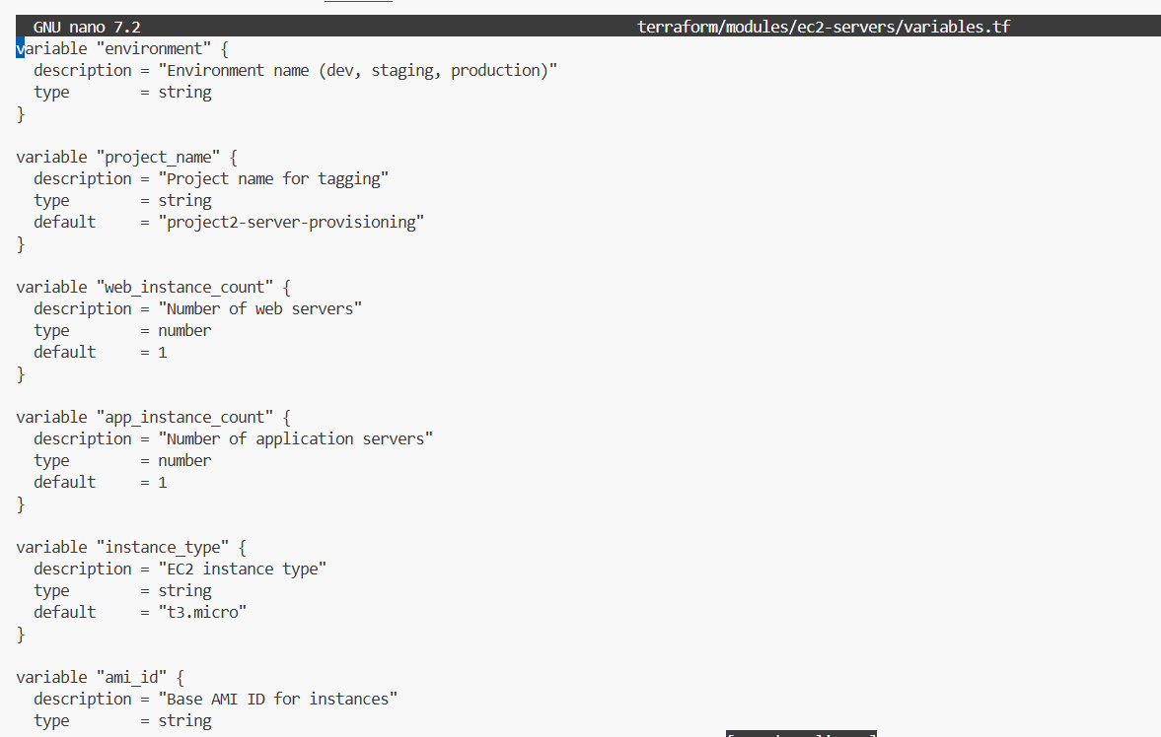

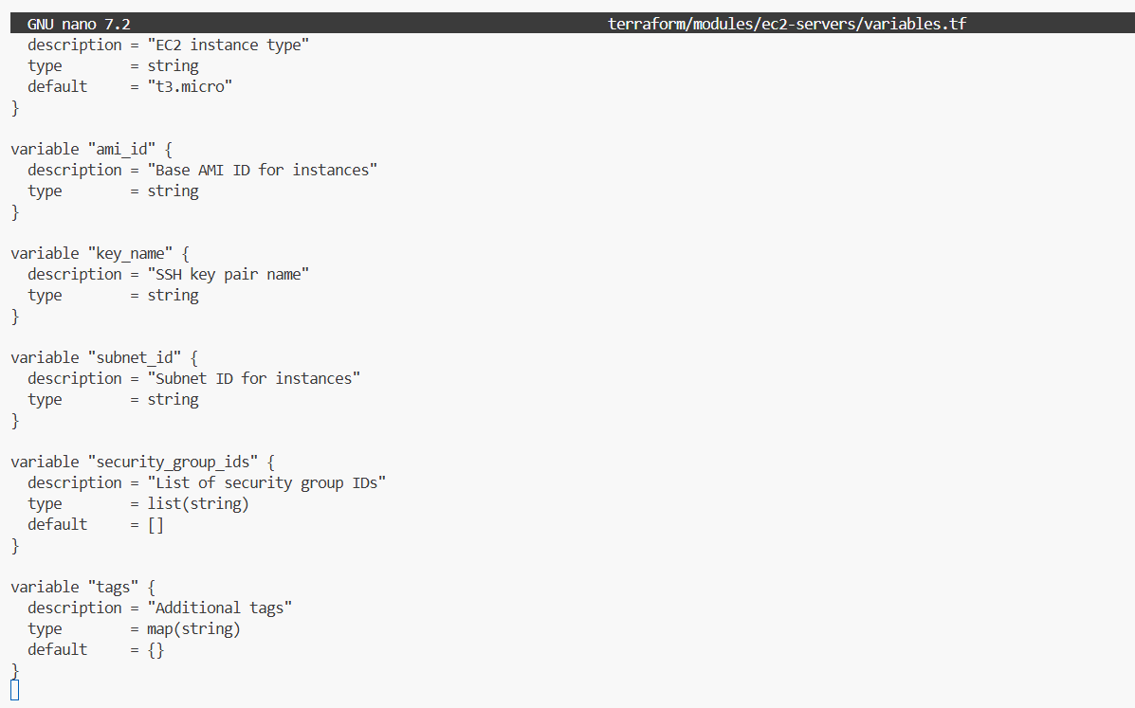

Screenshot: project2_part2_ec2_module_main.png

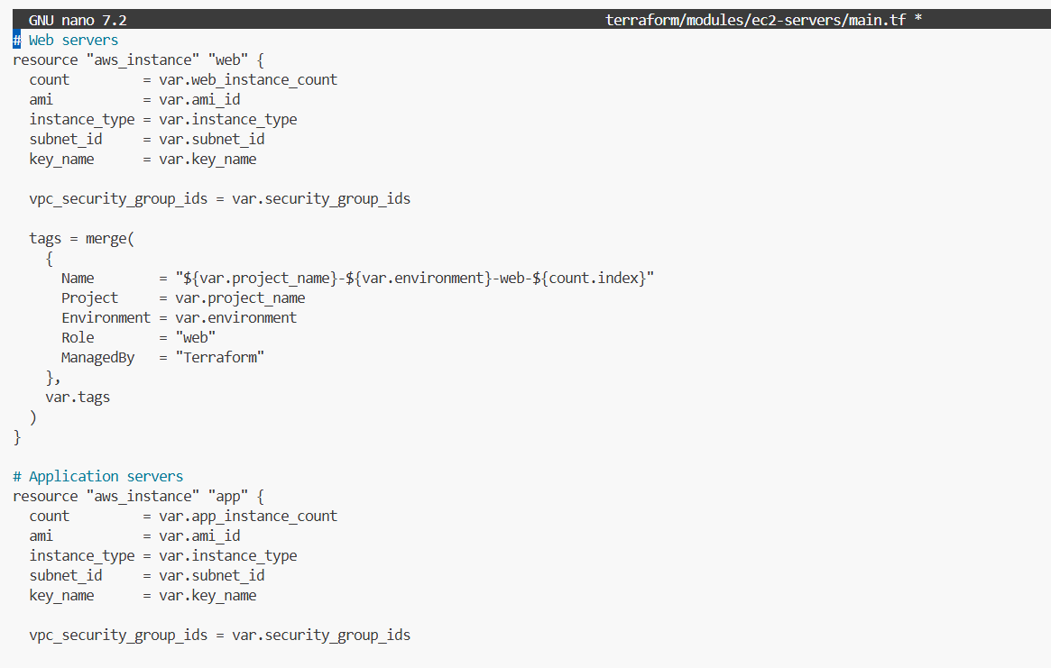

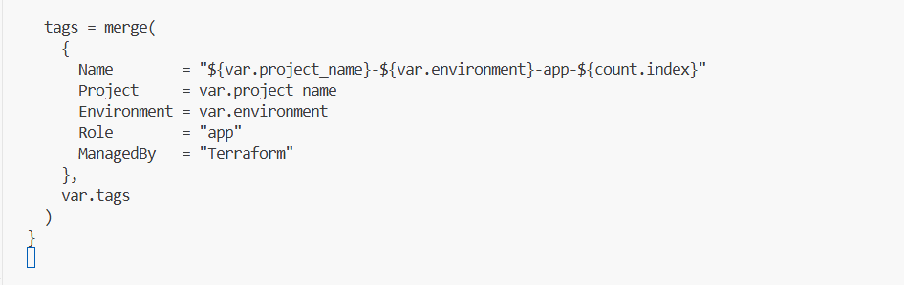

Screenshot: project2_part2_ec2_module_outputs.png

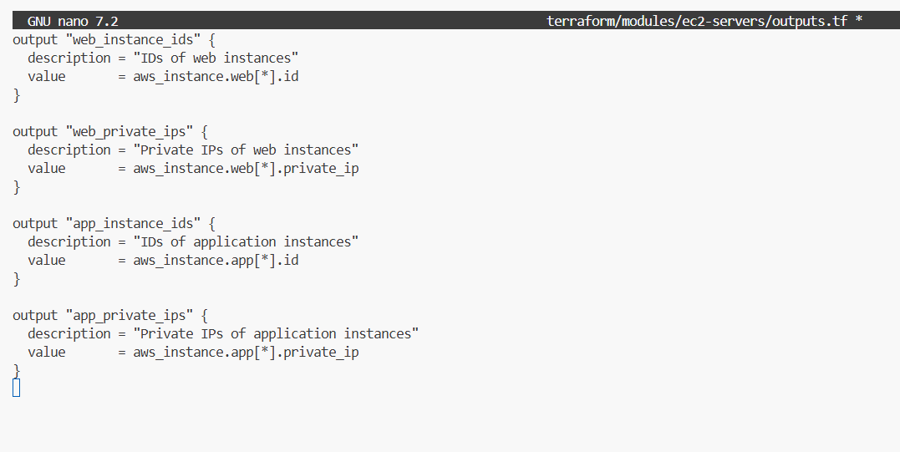

2.2 Root Terraform & Workspaces (15 marks)

Tasks:

Configure Terraform with AWS provider and default tags.

Implement workspace-dependent configuration via local.env_config.

Output summary information (counts, IPs).

Deliverables:

Screenshot: project2_part2_main_tf.png

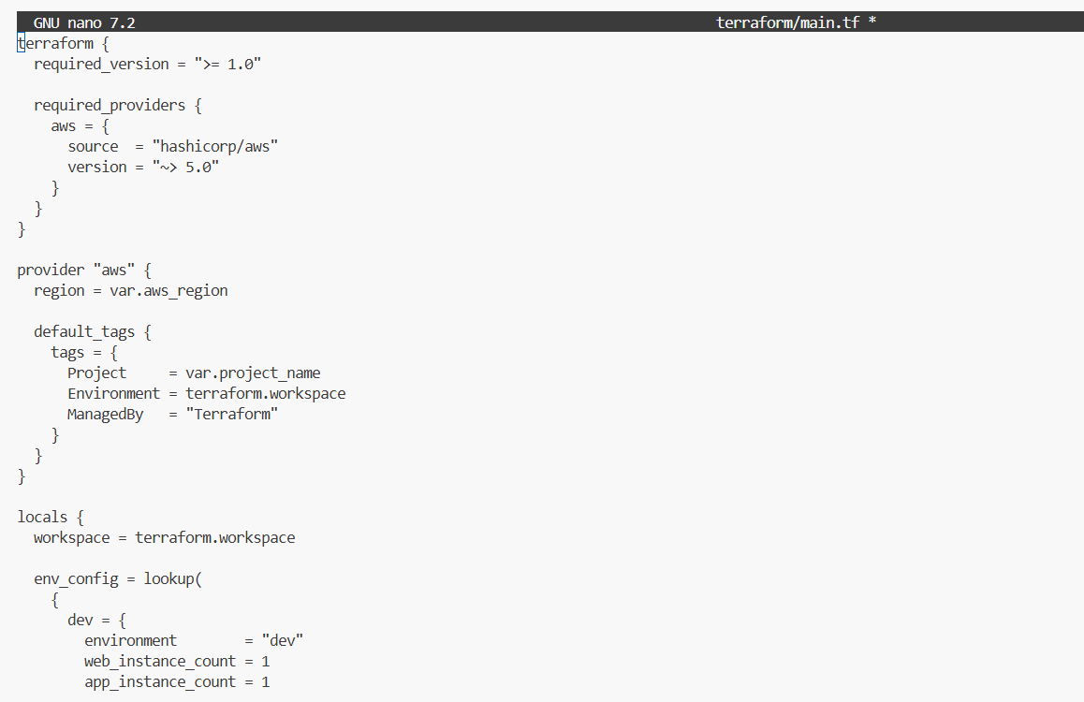

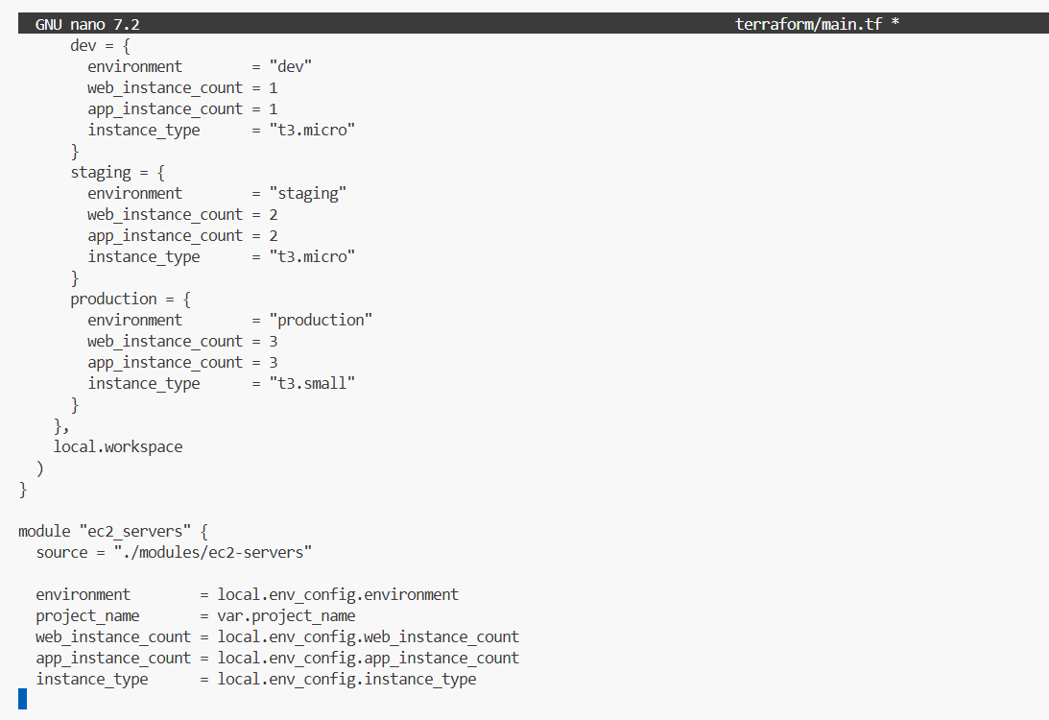

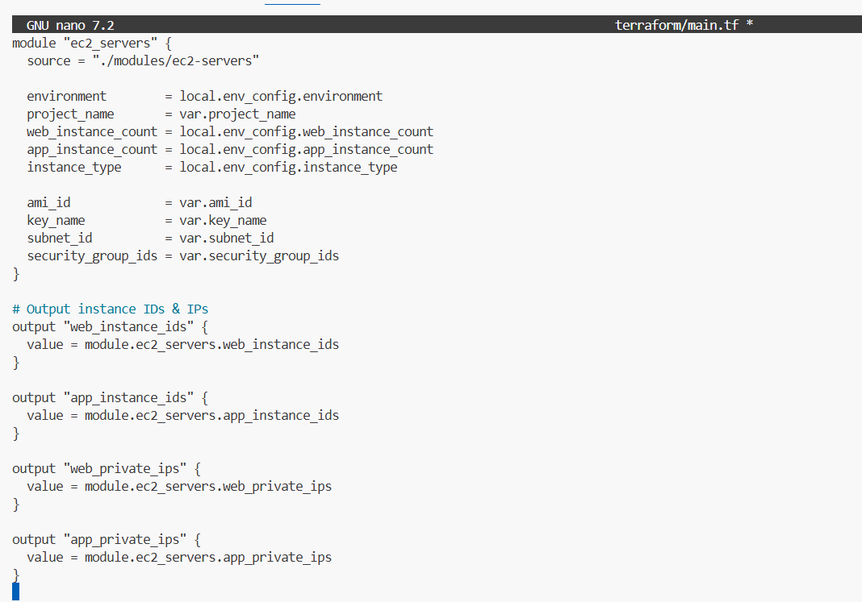

Screenshot: project2_part2_variables_tf.png

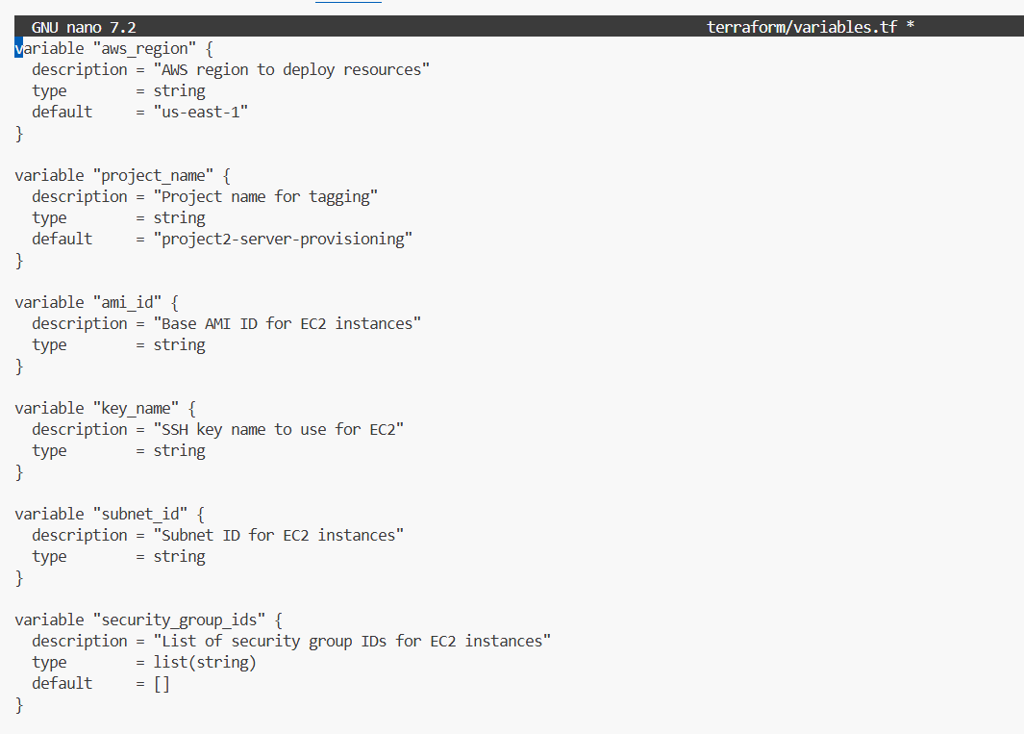

Screenshot: project2_part2_terraform_output.png

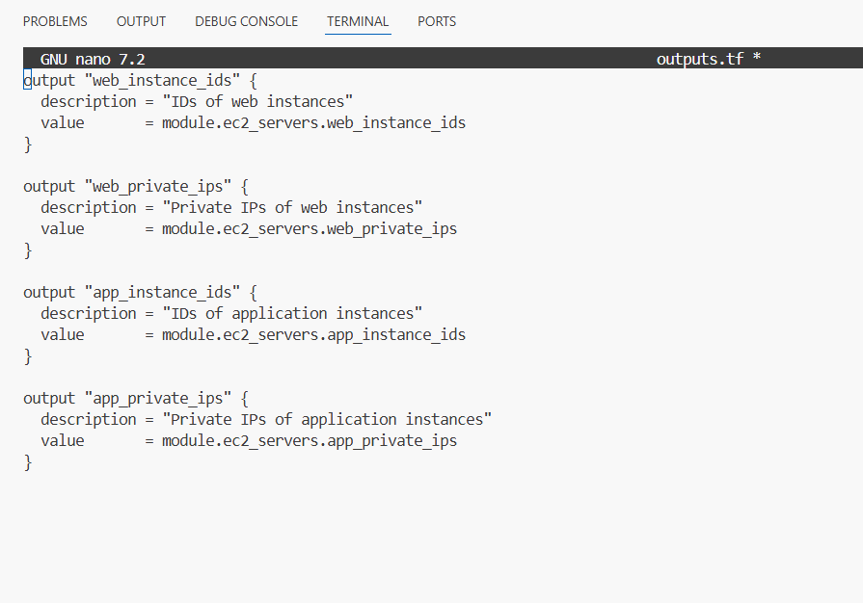

Dev Workspace

Heading: Dev Workspace – Terraform Output

Description:
This workspace provisions a single web and a single application EC2 instance for development.
The instances use t3.nano type to fit under our vCPU quota.
Private IPs and instance IDs are shown below.

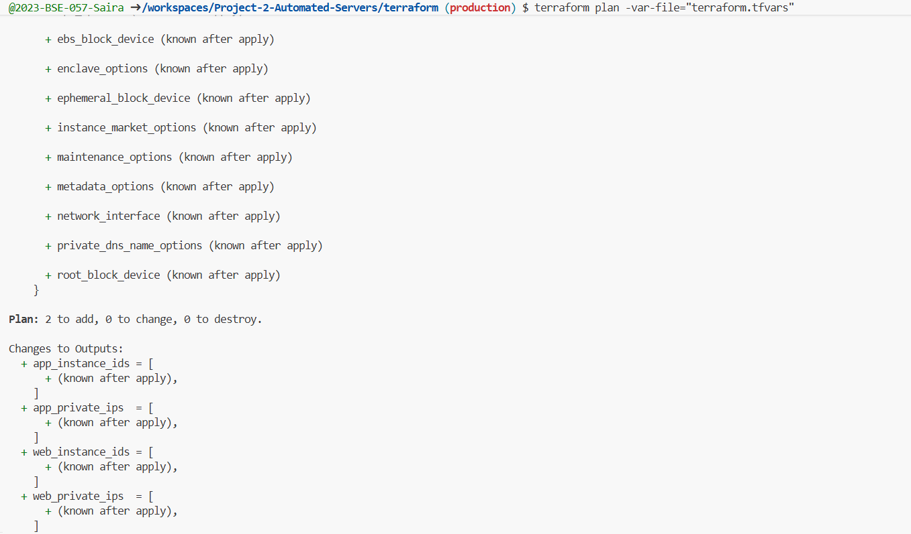

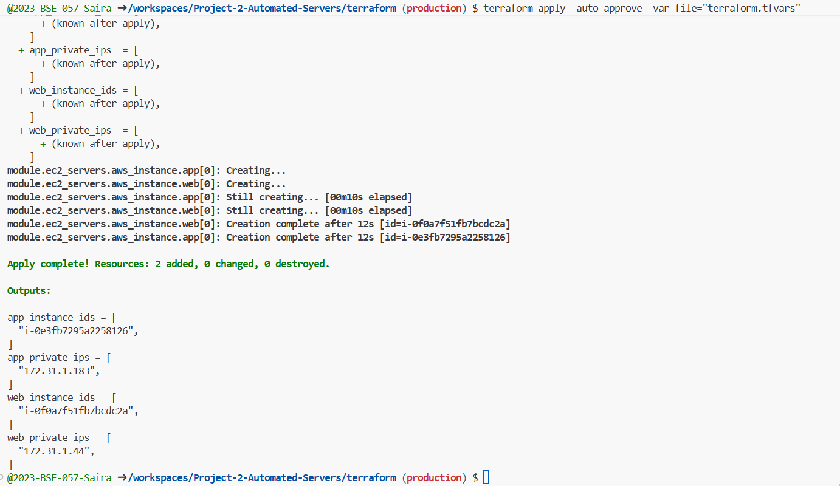

Staging Workspace

Heading: Staging Workspace – Terraform Output

Description:

Staging workspace provisions 2 web and 2 app instance for pre-production validation.
Used to test combined configuration and ensure automation works as expected.
IPs and instance IDs are displayed below.
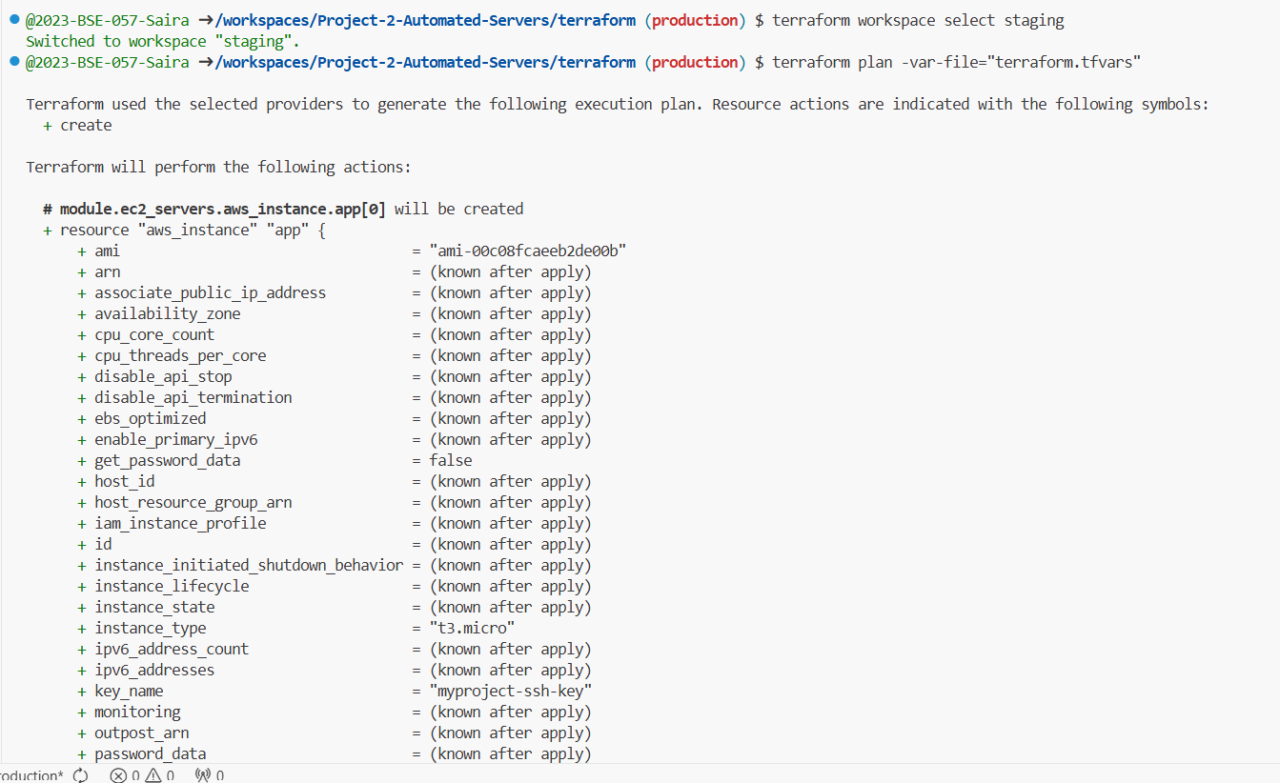

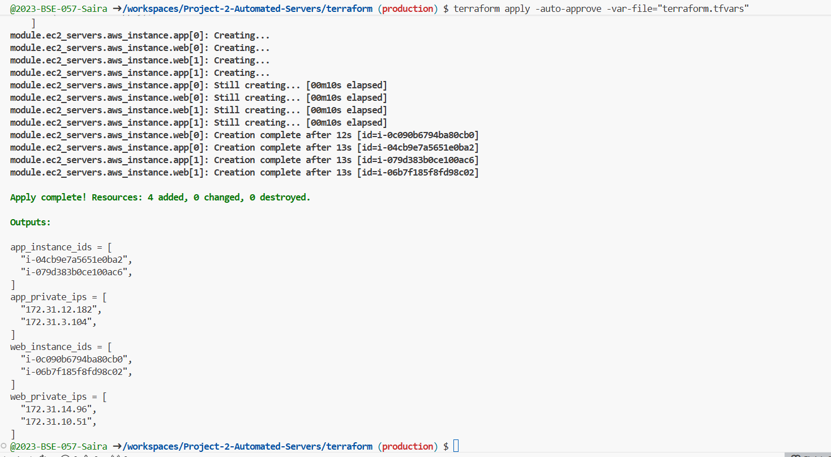

Production Workspace

Heading: Production Workspace – Terraform Output

Description:
Production workspace provisions 1 web and 1 app instance for live environment.
Minimal instance counts are used due to vCPU quota limits.
Private IPs and instance IDs are listed below.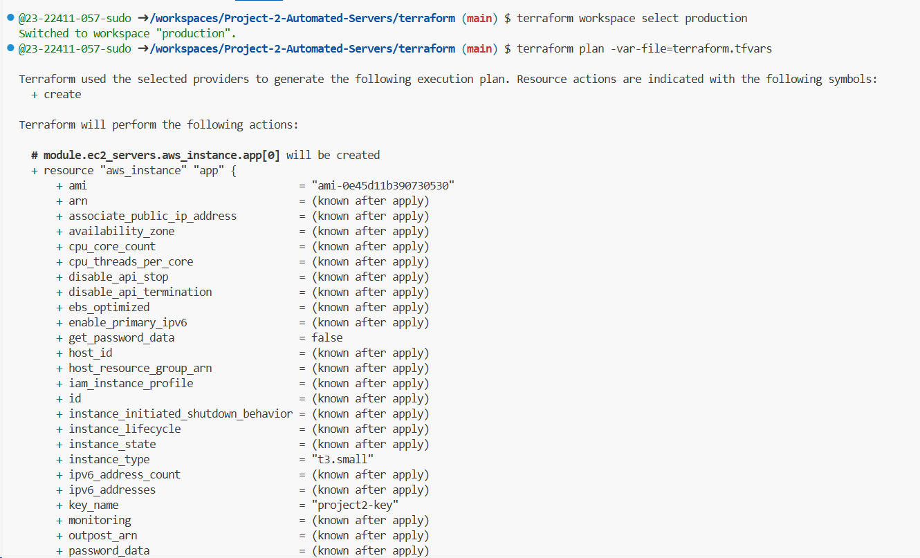

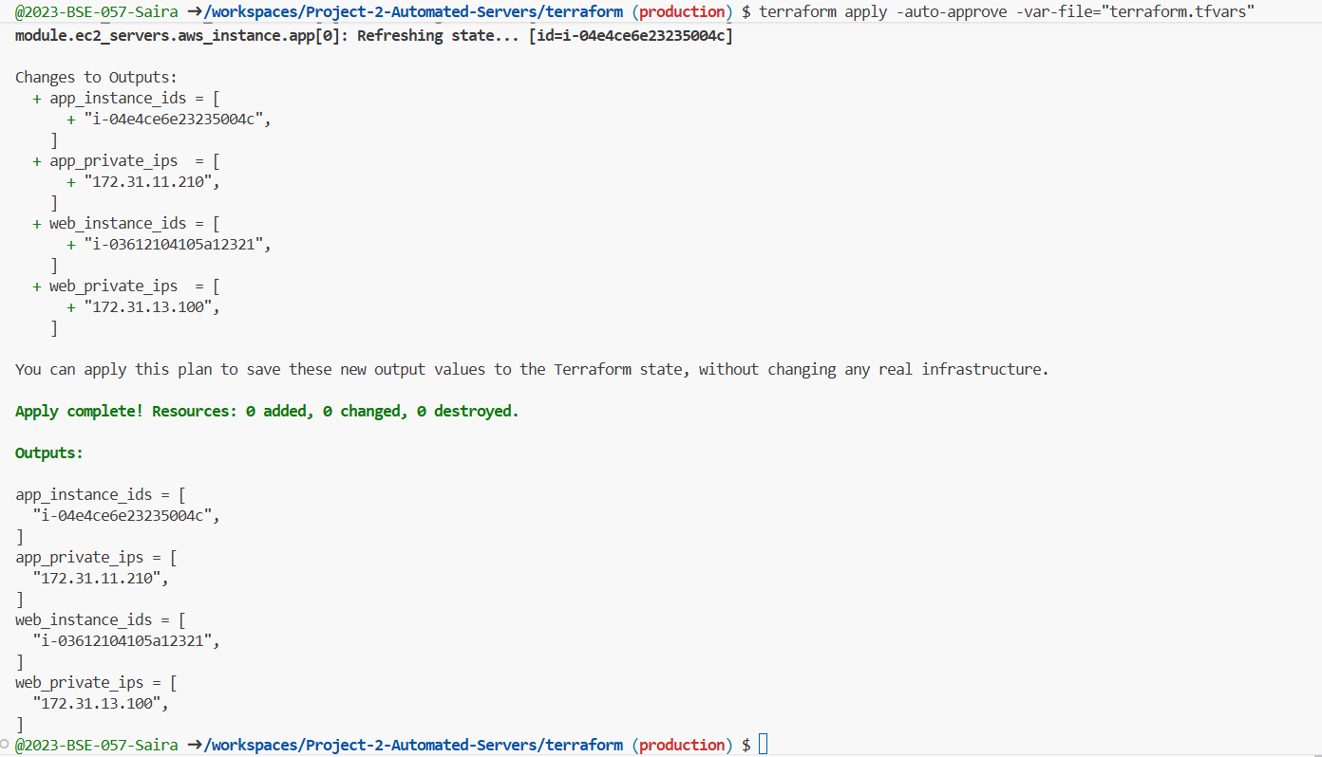

Ansible Roles & Playbooks

Ansible automates configuration management with the following roles:

hardening: Applies SSH hardening, installs required packages.

users: Creates the deployer user with SSH key access.

web: Installs Nginx and deploys a test web page.

app: Deploys application code and creates a systemd service.

Key playbooks:

configure-all.yml: Applies all roles.

detect-drift.yml: Checks for configuration drift, including service status and SSH configuration.

remediate-drift.yml: Restores the system to the desired configuration if drift is detected.

Part 3: Ansible Configuration & Dynamic Inventory (25 marks)

3.1 Ansible Configuration and Dynamic Inventory (10 marks)

Tasks:

Create dynamic inventory files for dev, staging, production.

Configure ansible.cfg.

Create group_vars/all.yml with reasonable defaults.

Deliverables:

Screenshot: project2_part3_ansible_inventory_dev.png

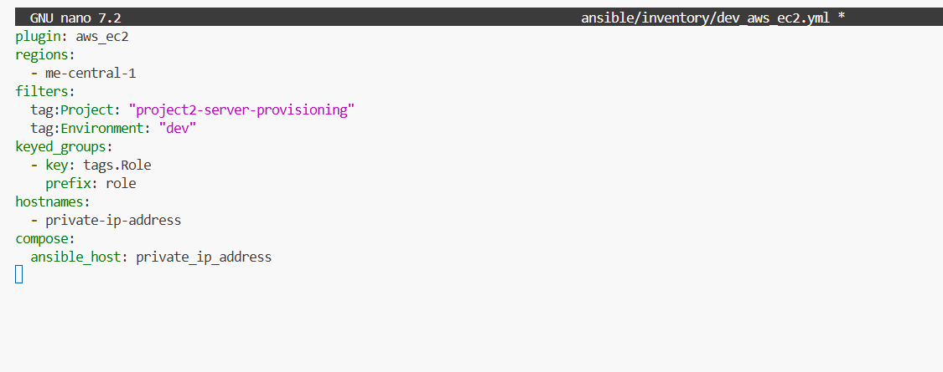

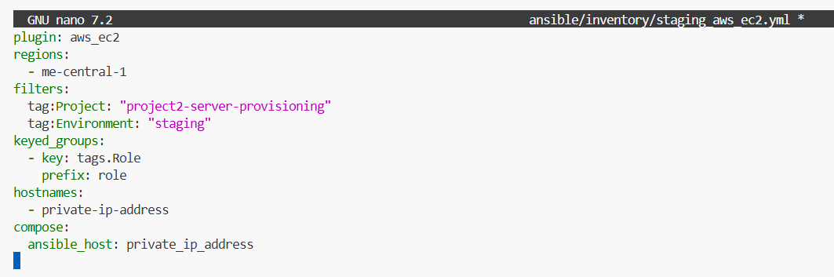

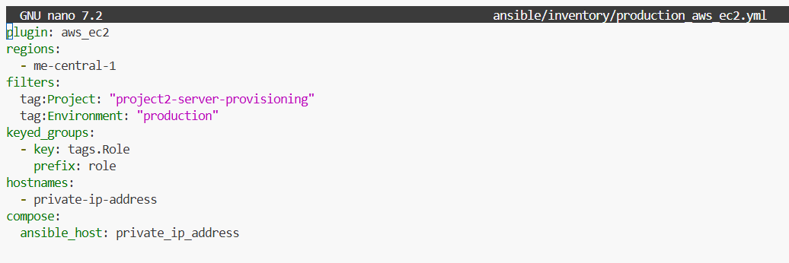

Screenshot: project2_part3_ansible_cfg.png

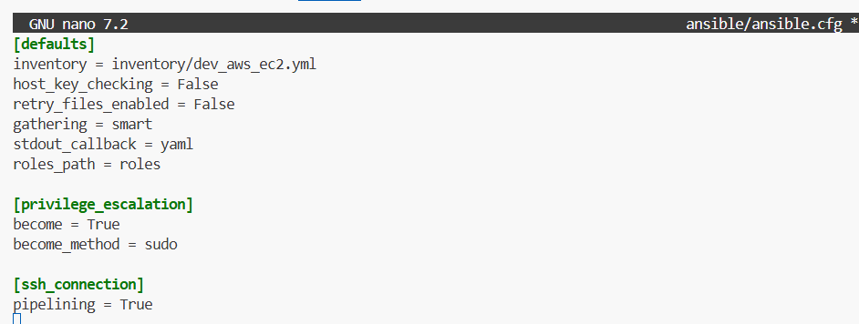

Screenshot: project2_part3_group_vars_all.png

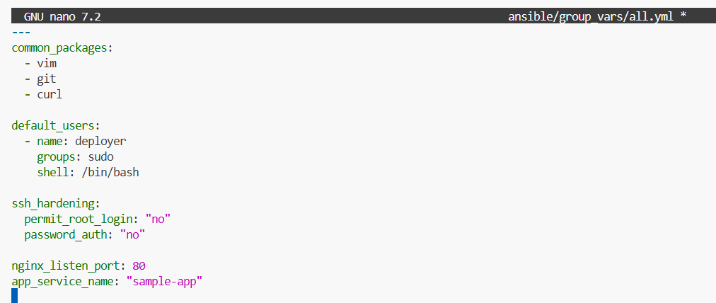

Ansible Dynamic Inventory for All Environments

Description:

This dynamic inventory uses the aws_ec2 plugin to automatically discover EC2 instances for dev, staging, and production environments based on tags.
Hosts are grouped by their Role tags (web or app), and connectivity is verified using the Ansible ping module.
The inventory ensures that playbooks can run seamlessly across all environments without manually listing hosts.

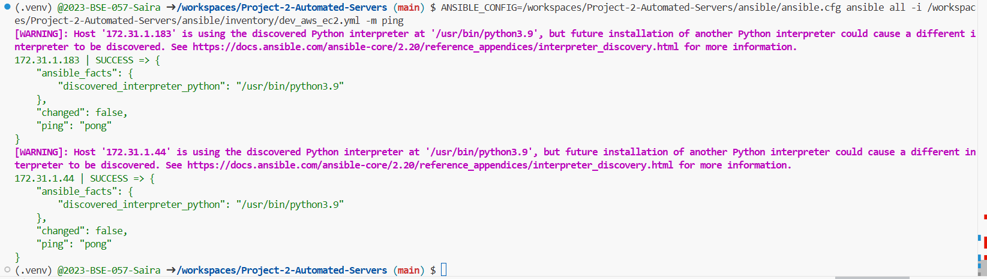

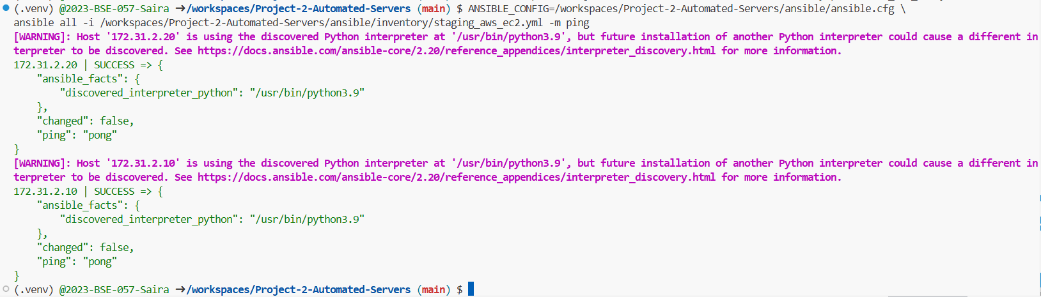

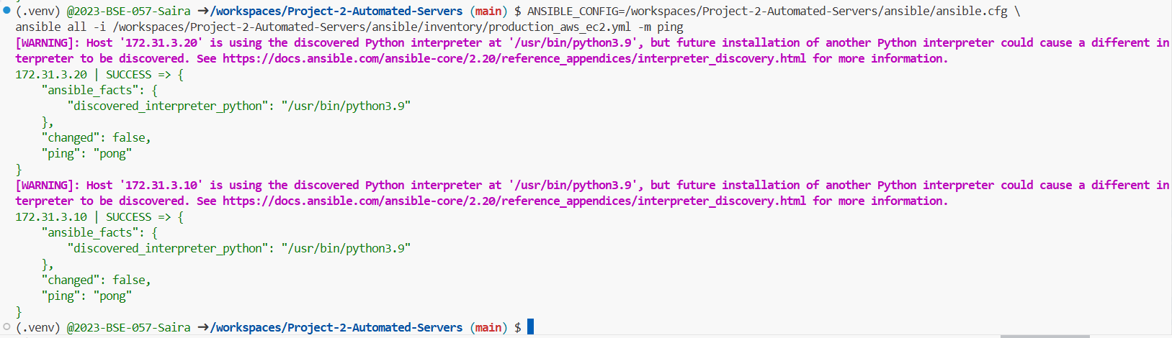

3.2 Ansible Roles for Hardening, Web, App, Users (15 marks)

Tasks:

Implement roles: hardening, users, web, app.

Make roles idempotent (re-runs should not fail or re-change unnecessarily).

Verify that web servers and app servers are correctly configured by role and hardened.

Deliverables:

Screenshot: project2_part3_roles_structure.png

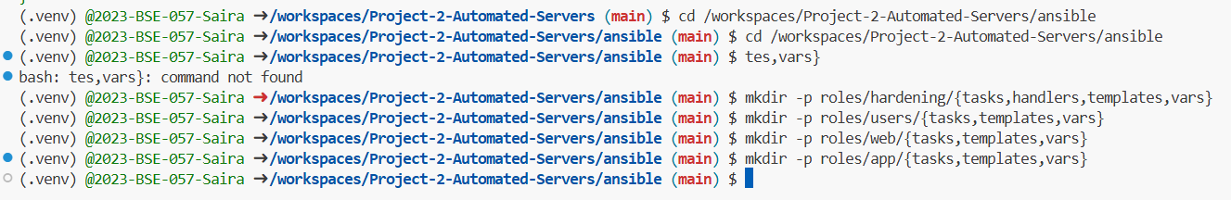

Screenshot: project2_part3_hardening_role_main.png

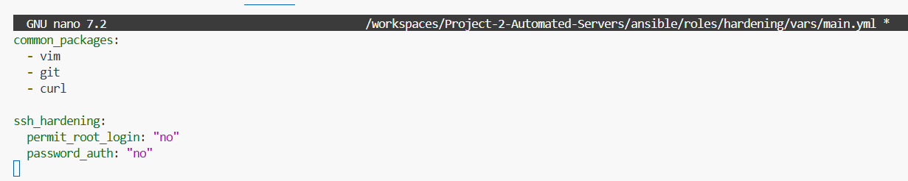

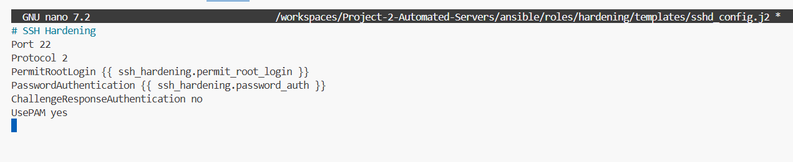

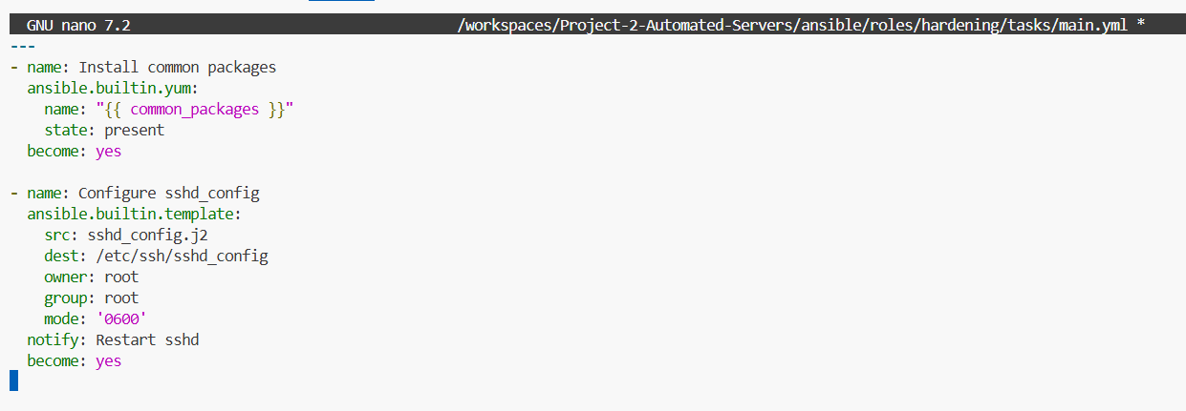

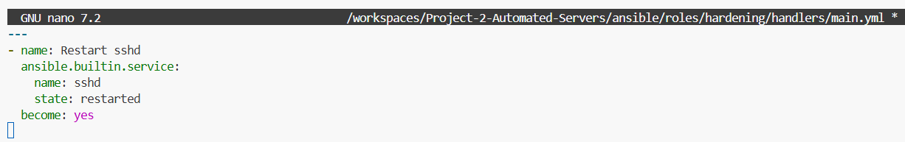

Screenshot: project2_part3_web_role_main.png

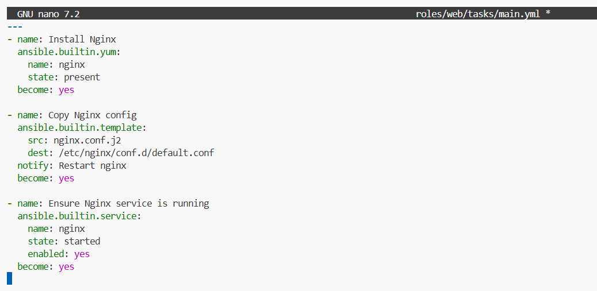

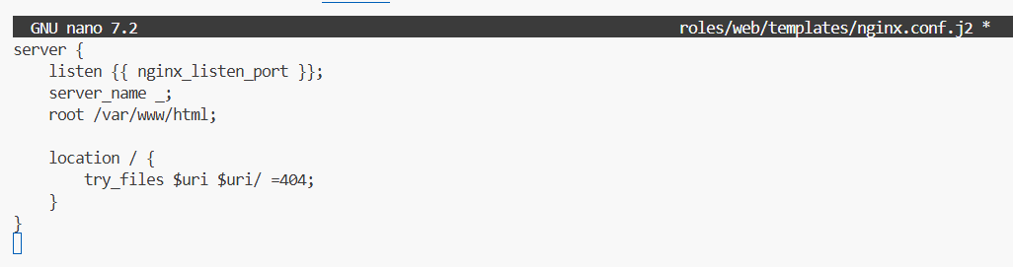

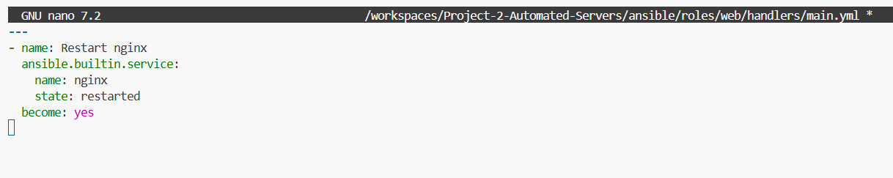

Screenshot: project2_part3_app_role_main.png

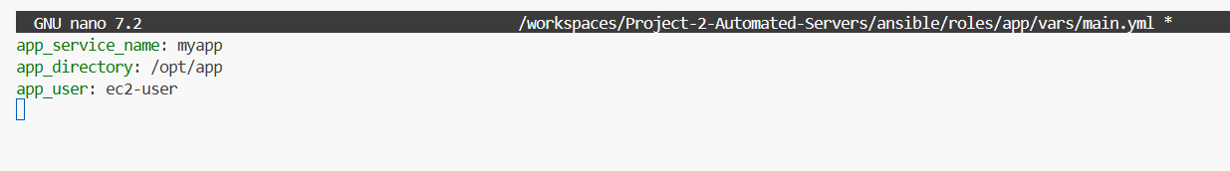

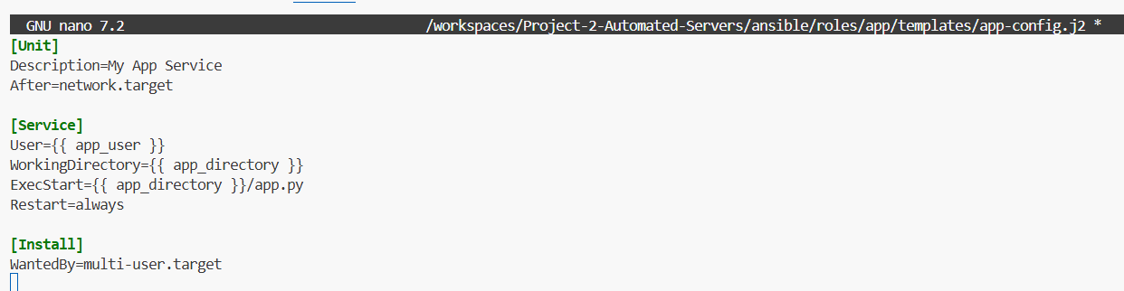

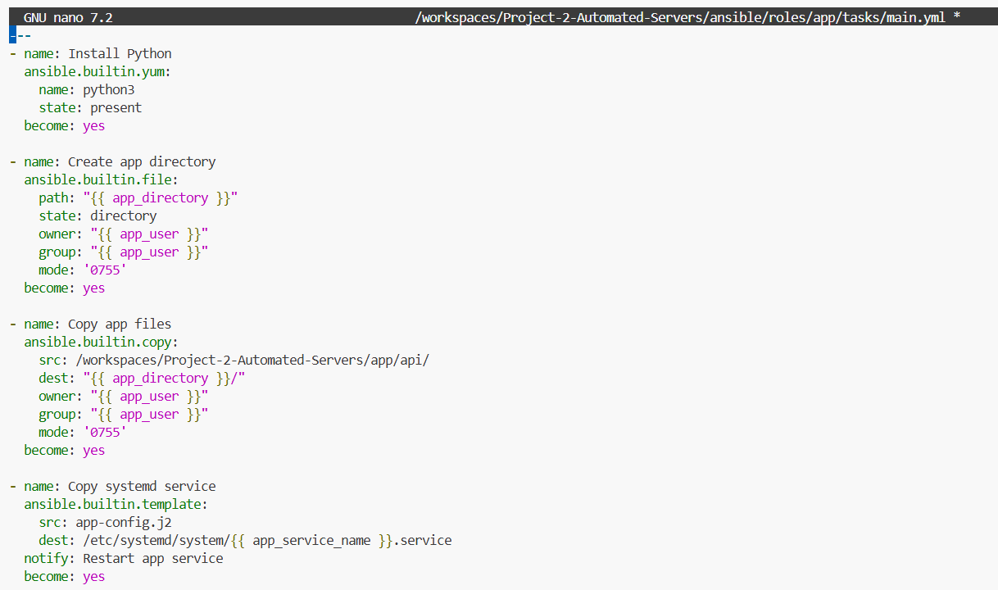

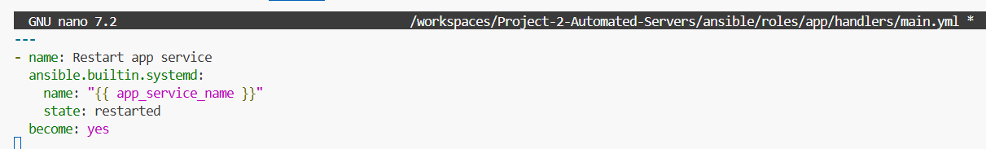

Screenshot: project2_part3_configure_all_execution.png

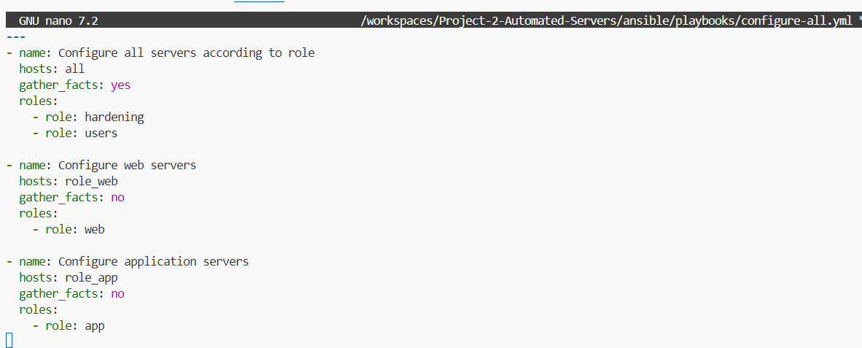

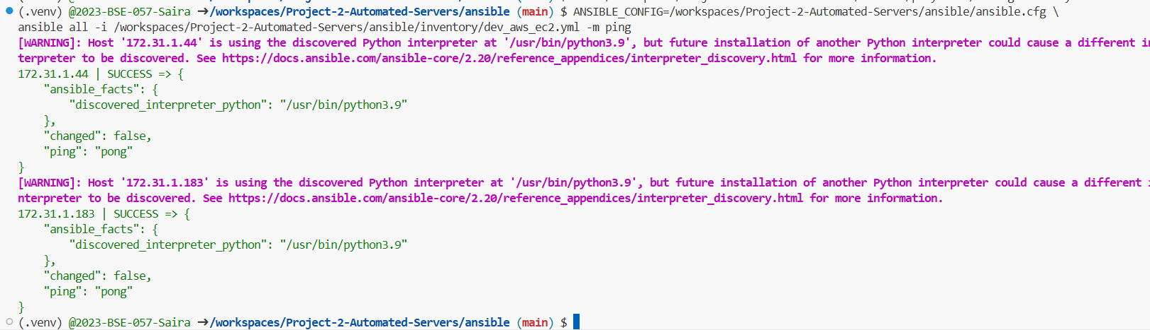

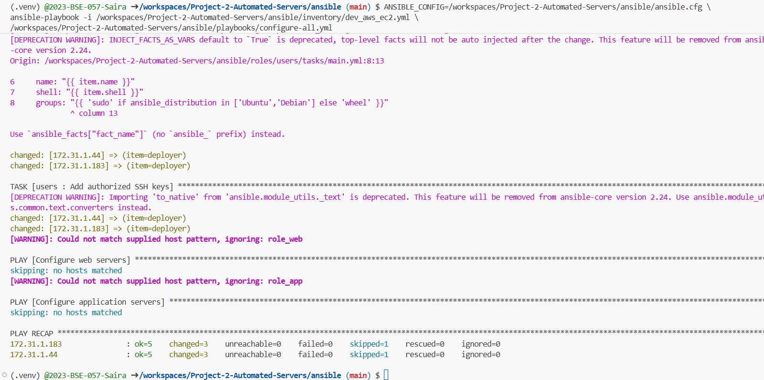

Drift Detection & Remediation

Terraform plan is used to detect configuration drift by comparing the desired state with the actual infrastructure. If drift is detected, Terraform apply is executed to restore the correct configuration. This ensures infrastructure consistency and reliability.

Part 4: Configuration Drift Detection & Remediation (20 marks)

4.1 Drift Detection (10 marks)

Tasks:

Implement detect-drift.yml that surfaces deviations clearly.

Demonstrate a run where there is no drift and a run where you have manually changed something.

Deliverables:

Screenshot: project2_part4_detect_drift_playbook.png

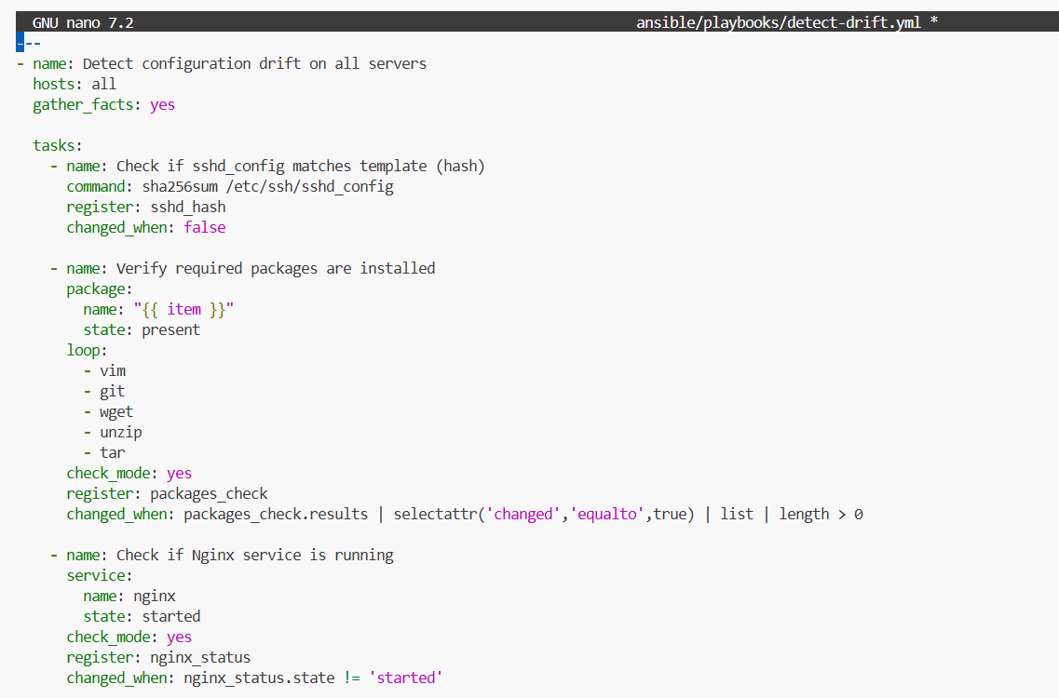

Screenshot: project2_part4_detect_drift_execution.png

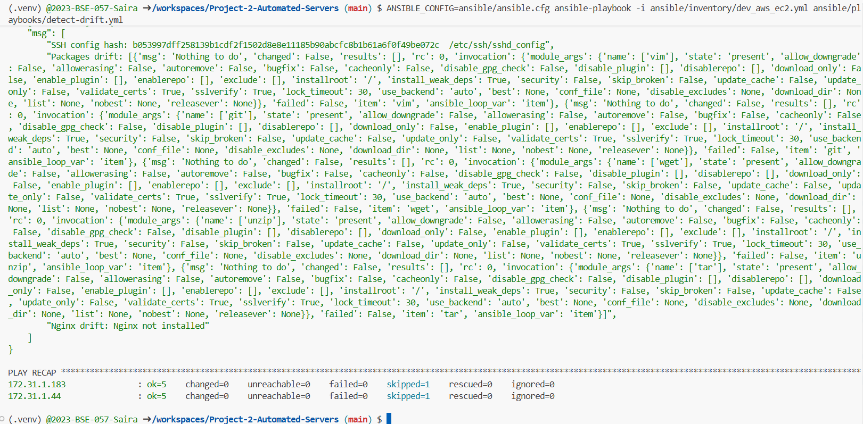

4.2 Drift Remediation (10 marks)

Tasks:

Implement remediate-drift.yml.

Show before/after evidence in screenshots/logs.

Deliverables:

Screenshot: project2_part4_remediate_drift_playbook.png

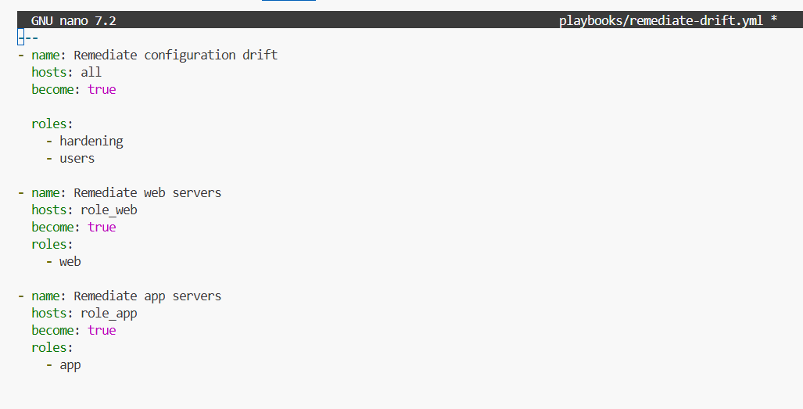

Screenshot: project2_part4_remediate_drift_execution.png

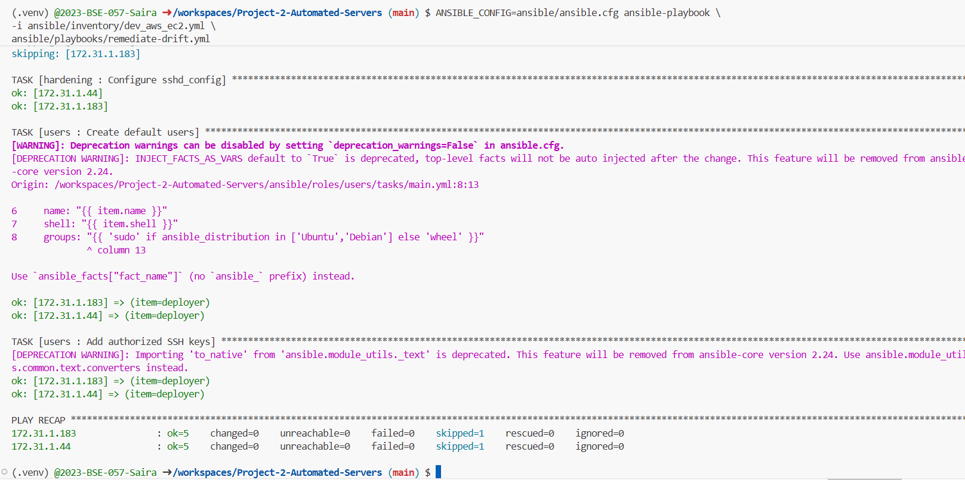

Part 5: CI/CD and End-to-End Provisioning (10 marks)

5.1 Optional GitHub Actions Workflows (5 marks)

Deliverables:

Screenshot: project2_part5_dev_workflow_run.png

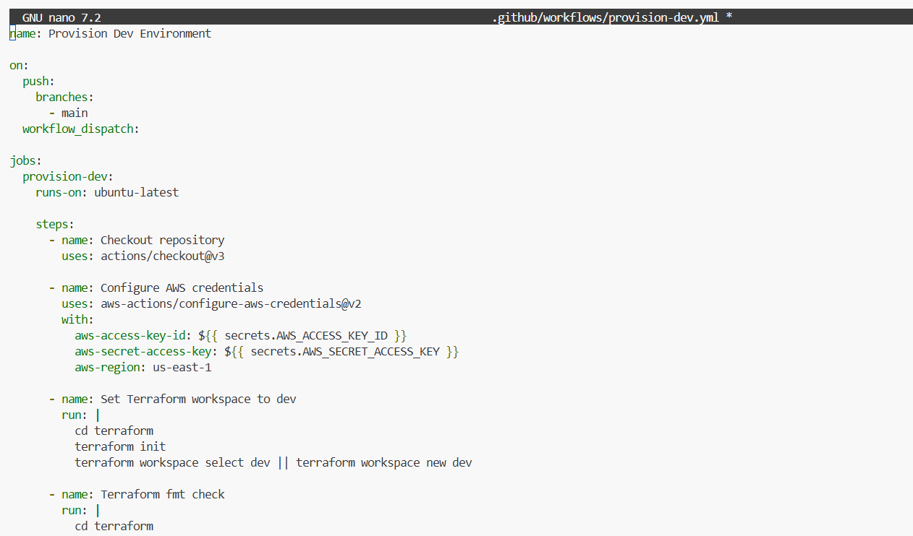

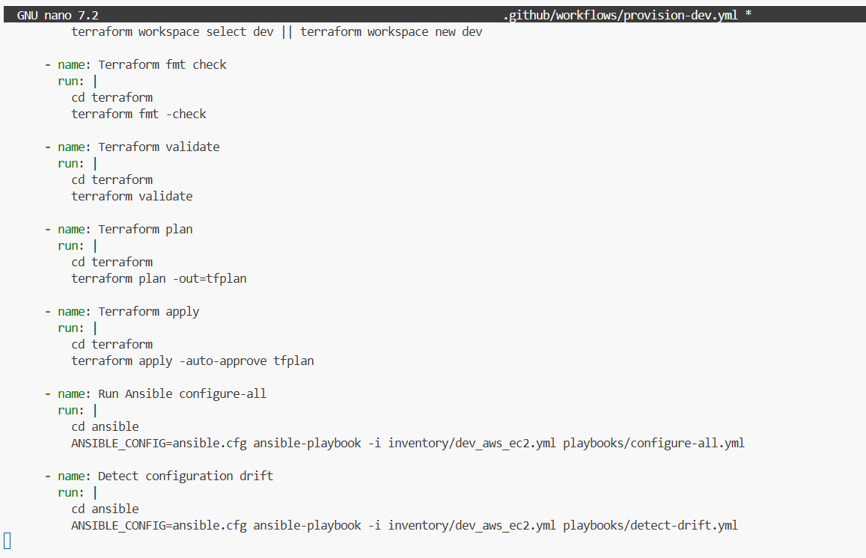

(If not using Actions, describe your manual pipeline in the report.)

End-to-End Provisioning Test

An end-to-end test was performed in the development workspace. Terraform provisioned the servers, Ansible verified connectivity using ping, and services were configured successfully. The web service was accessed via browser, and the application service ran correctly.

5.2 End-to-End Provisioning Test (5 marks)

Deliverables:

Screenshot: project2_part5_end_to_end_terraform_apply.png

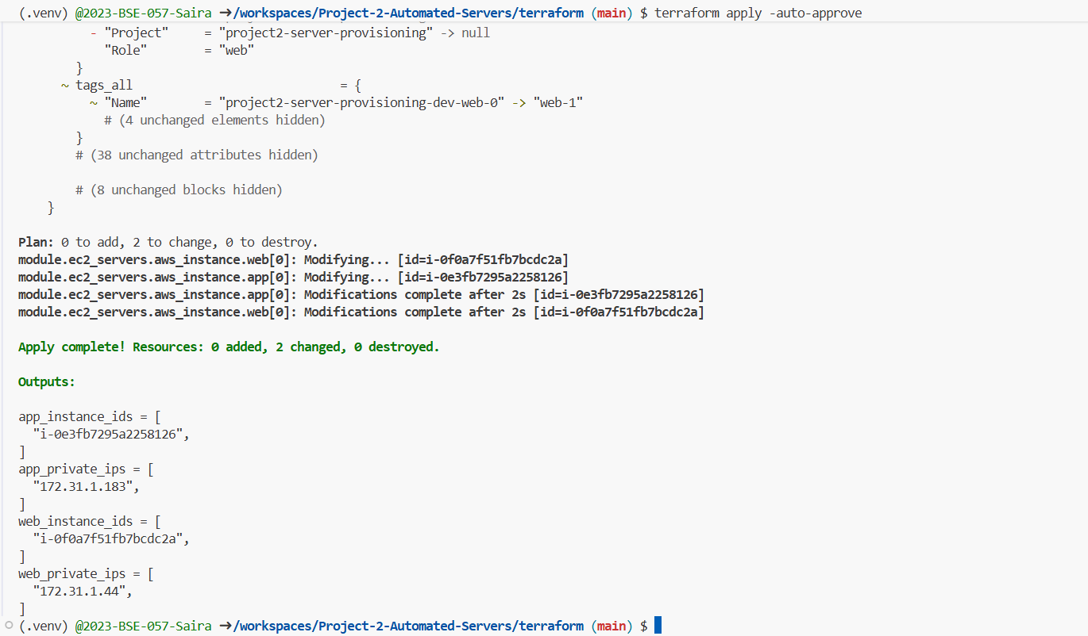

Screenshot: project2_part5_end_to_end_ansible_run.png

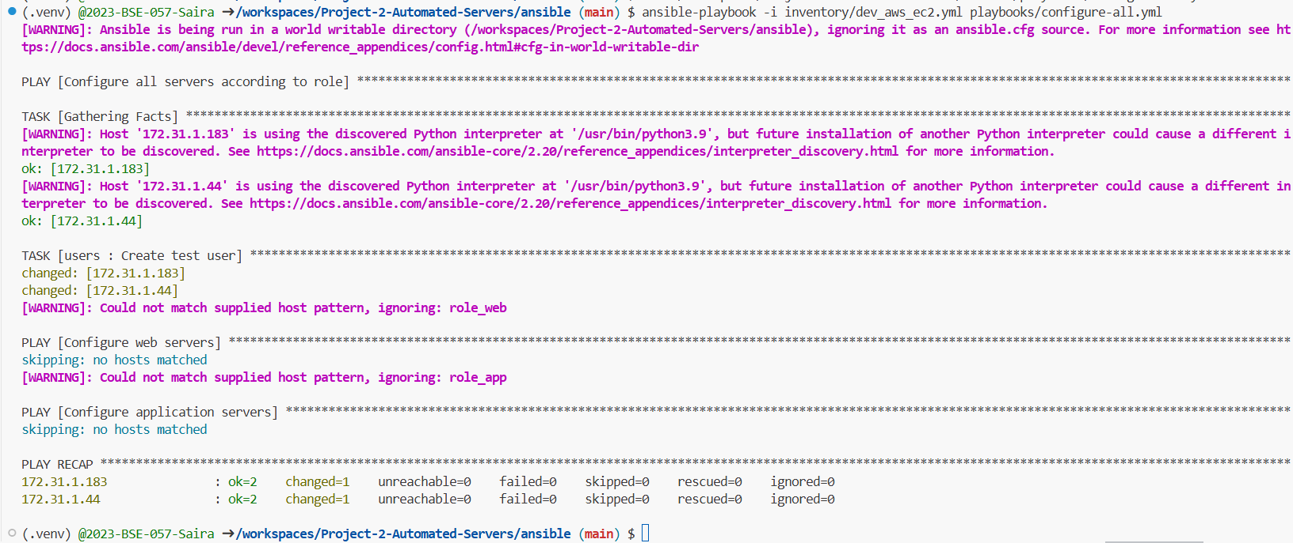

Screenshot: project2_part5_web_and_app_validation.png

SSH into the Web server

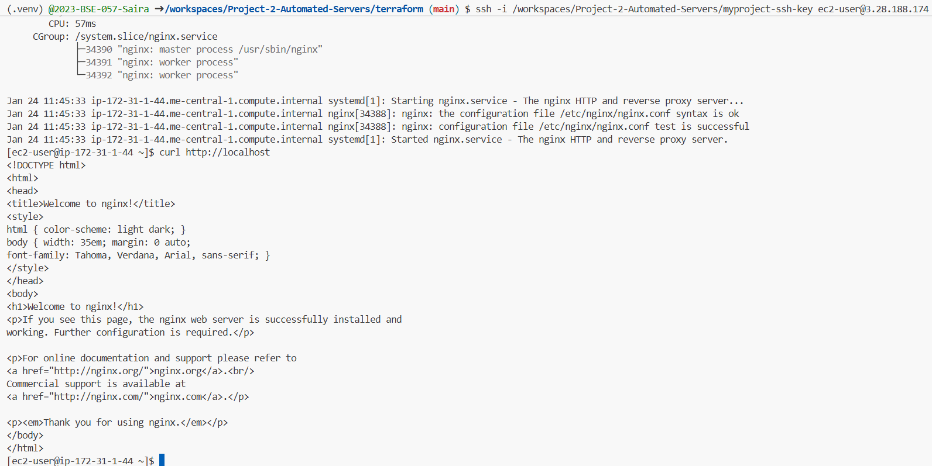

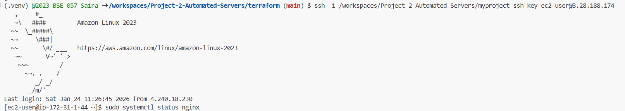

Browser Testing



SSH into the App server

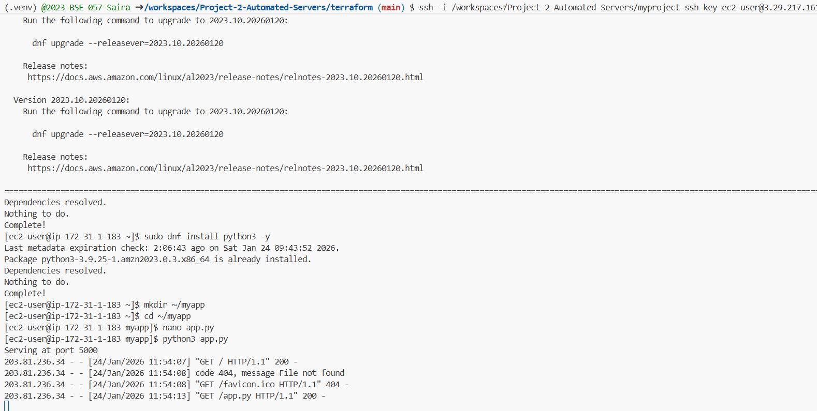

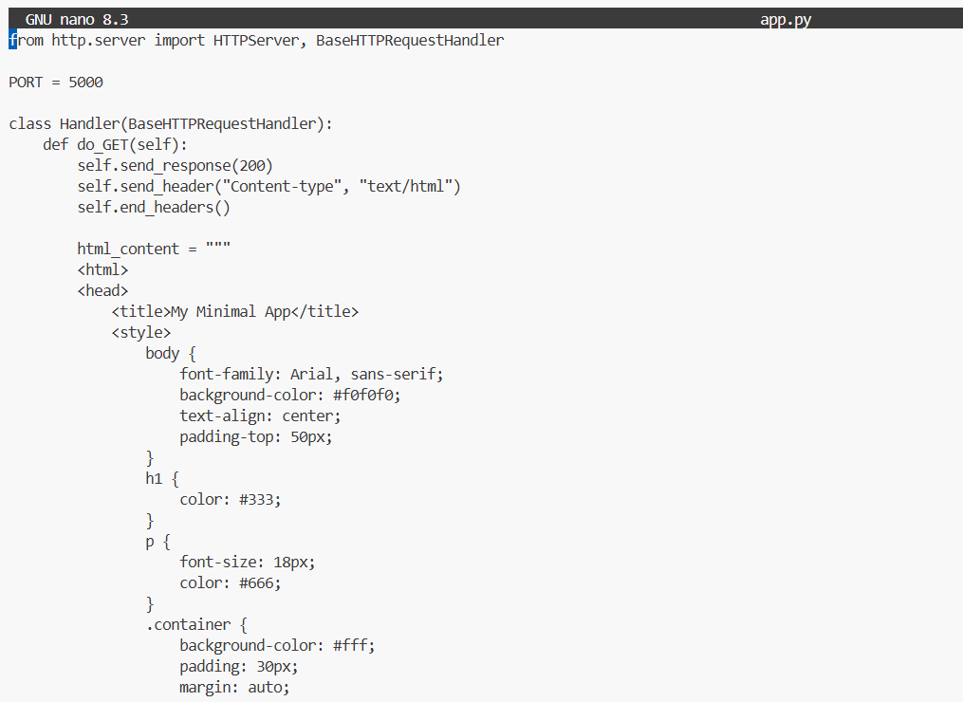

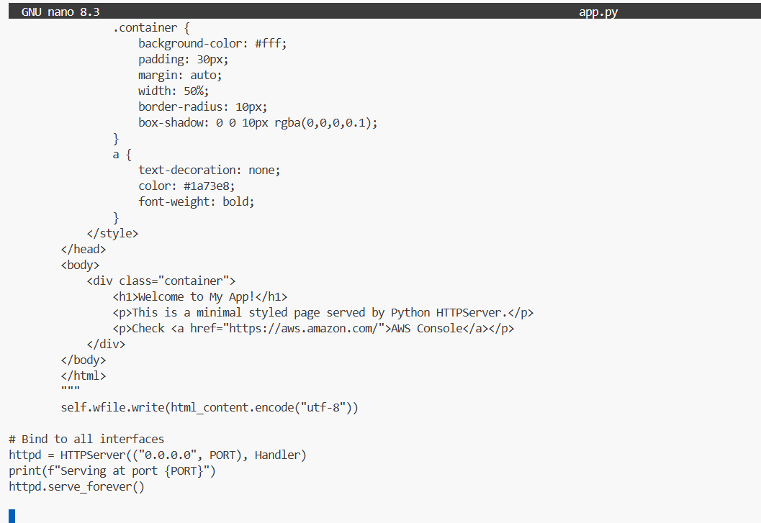

Browser Testing

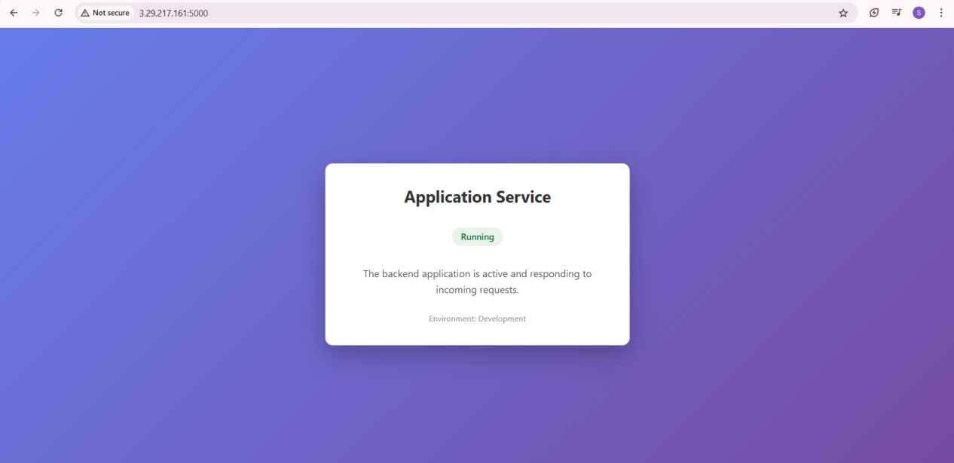

Challenges & Solutions

SSH access failed initially due to private IPs only; resolved by adding public IP outputs.

Ansible tasks failed due to permission issues; fixed using become: yes.

Missing or incorrect Ansible roles caused errors; roles were corrected or removed.

Terraform module errors occurred due to mismatched variables and outputs; resolved by aligning module definitions.

Conclusion

The project successfully demonstrates automated infrastructure provisioning and configuration using Terraform and Ansible. The final system is modular, reliable, and scalable. Practical challenges were resolved through troubleshooting, making the solution suitable for real-world DevOps workflows.

Appendices

This section contains Terraform configurations, Ansible playbooks, inventory files, logs, and screenshots demonstrating successful execution.

Installations:

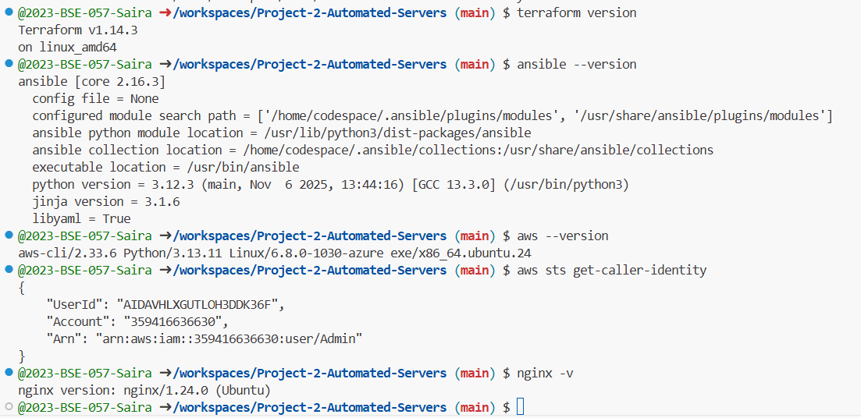

Files Creation:

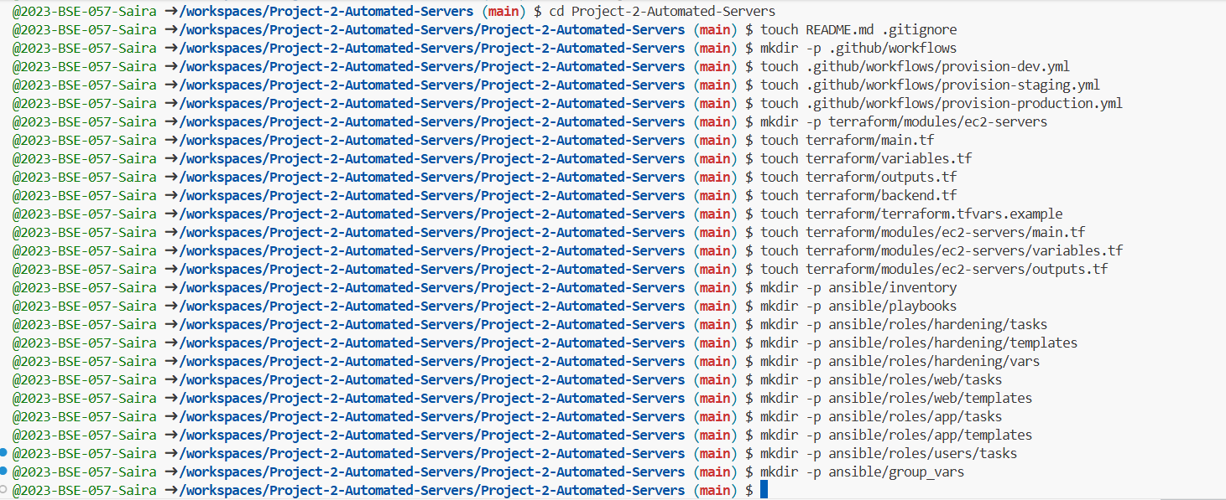

Ansible testing:

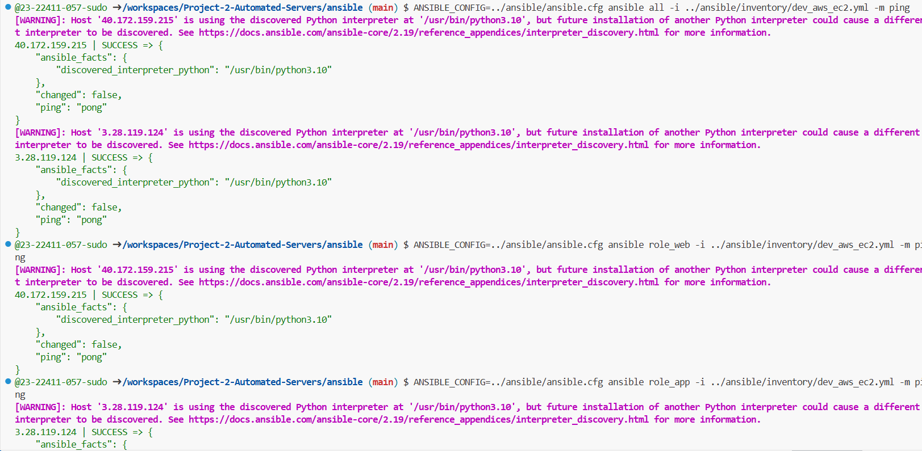

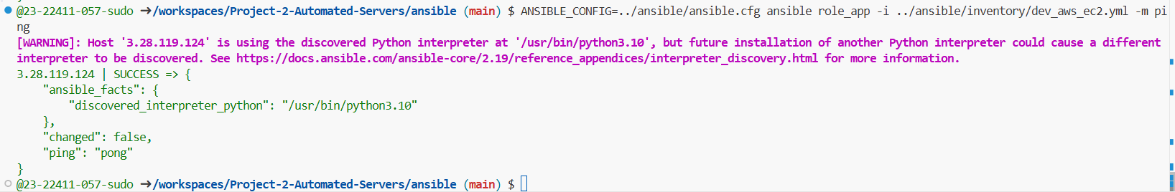

Staging Workflow – .github/workflows/provision-staging.yml

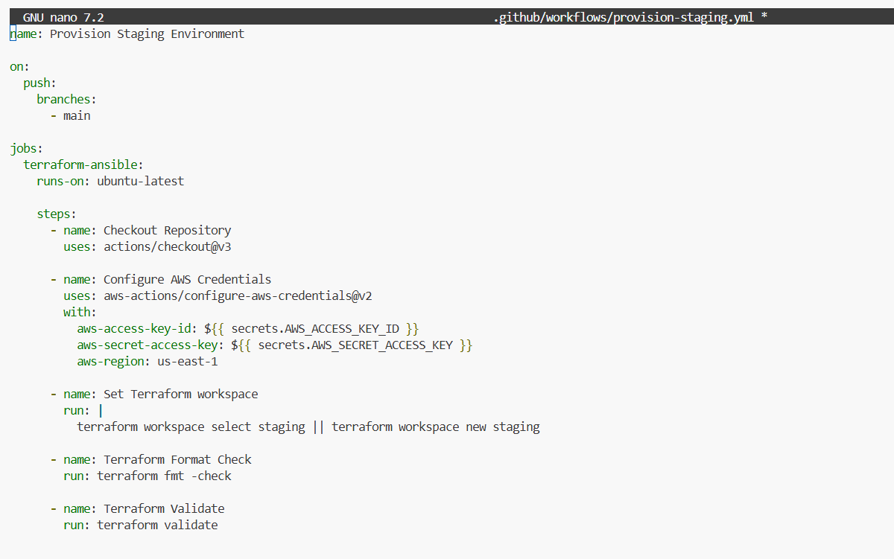

Production Workflow – .github/workflows/provision-production.yml

